**DATABASE SCHEMA**

**Command used :**

CREATE TABLE app (

id SERIAL PRIMARY KEY,

app_name VARCHAR(100) NOT NULL,

version VARCHAR(20) NOT NULL,

description VARCHAR(500)

);

**Database structure**

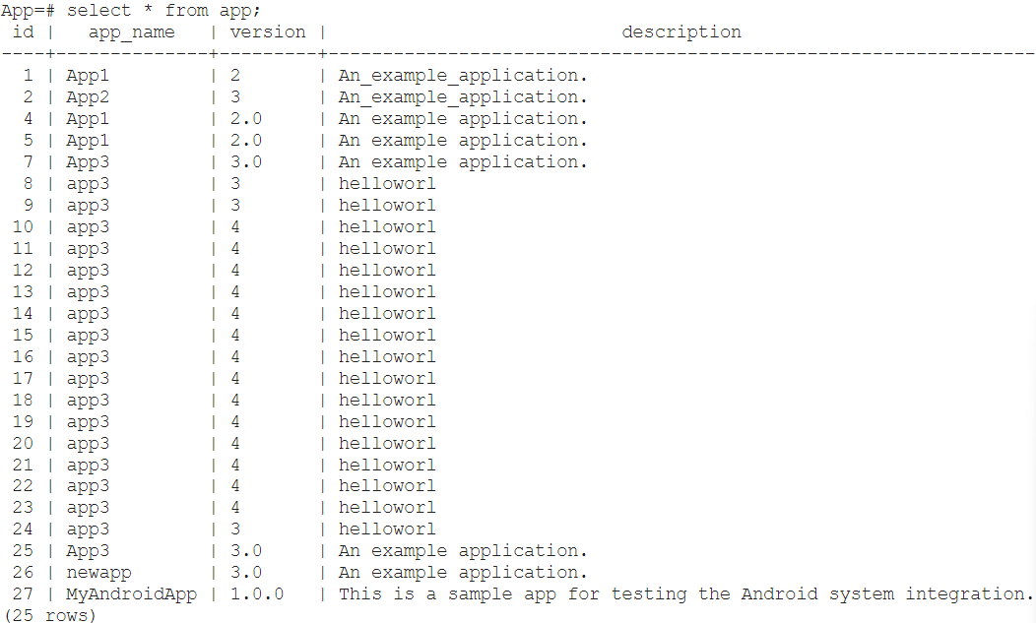

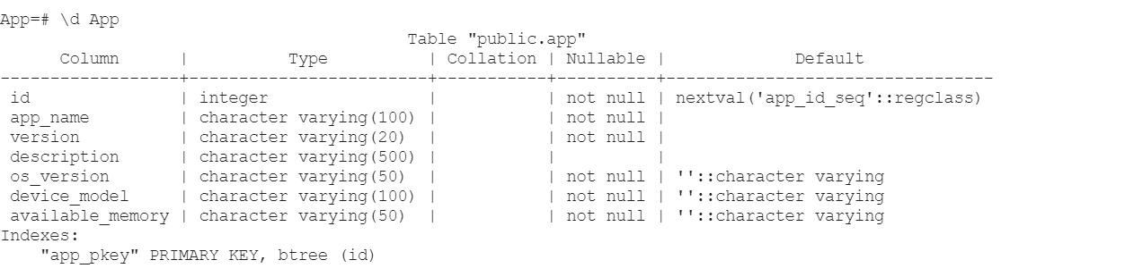

**TEST DATASETS FOR THE API IS HERE:**

**IN THE FORM OF JSON FILE**

[

{

"id": 1,

"app_name": "WeatherPro",

"version": "1.0.0",

"description": "A weather forecast app with real-time updates."

},

{

"id": 2,

"app_name": "TaskManager",

"version": "2.1.3",

"description": "An app to manage your daily tasks and schedules."

},

{

"id": 3,

"app_name": "FitTracker",

"version": "3.5.7",

"description": "A fitness tracking app for workouts and calorie counting."

},

{

"id": 4,

"app_name": "MusicStream",

"version": "5.0.2",

"description": "A music streaming app with curated playlists and offline mode."

},

{

"id": 5,

"app_name": "NoteIt",

"version": "4.0.0",

"description": "A simple note-taking app with cloud sync and collaboration."

}

]